Andy Ni

COMP 3710

Assignment 4

1. User runs the app and UI pops up

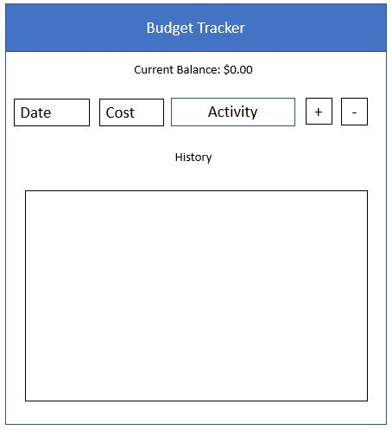

1. Enter a Date, Cost, and Activity and click on the plus button

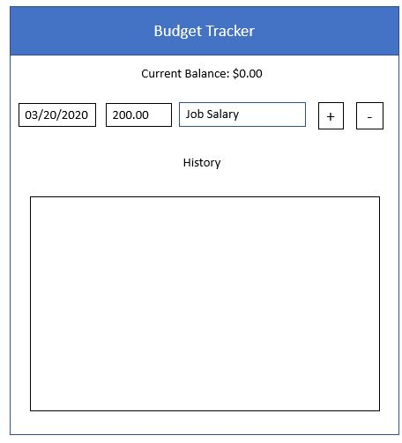

1. App will update balance and history from user actions

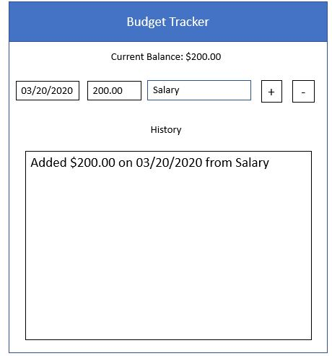

1. User enters new activity where they spend money and click on the minus button

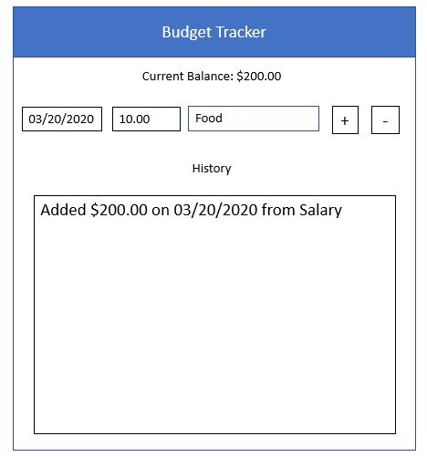

1. App updates balance and history

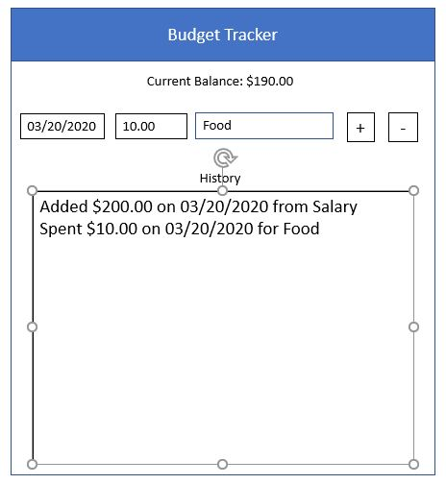

1. User closes and reopens app will display previous user information using shared preferences

